Created with draw.io : <https://app.diagrams.net/>

Draw.io is a proprietary software for making [diagrams](https://www.computerhope.com/jargon/d/diagram.htm) and [charts](https://www.computerhope.com/jargon/c/chart.htm).

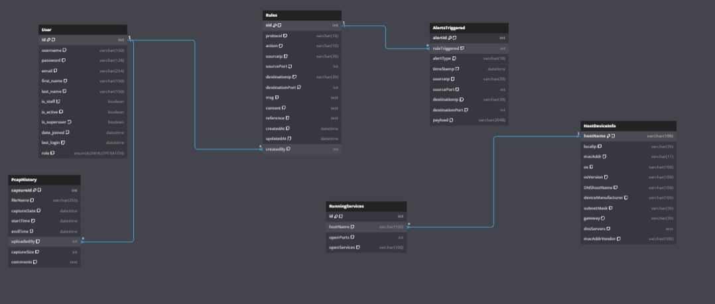

Figure 1:Entity Relation First Iteration

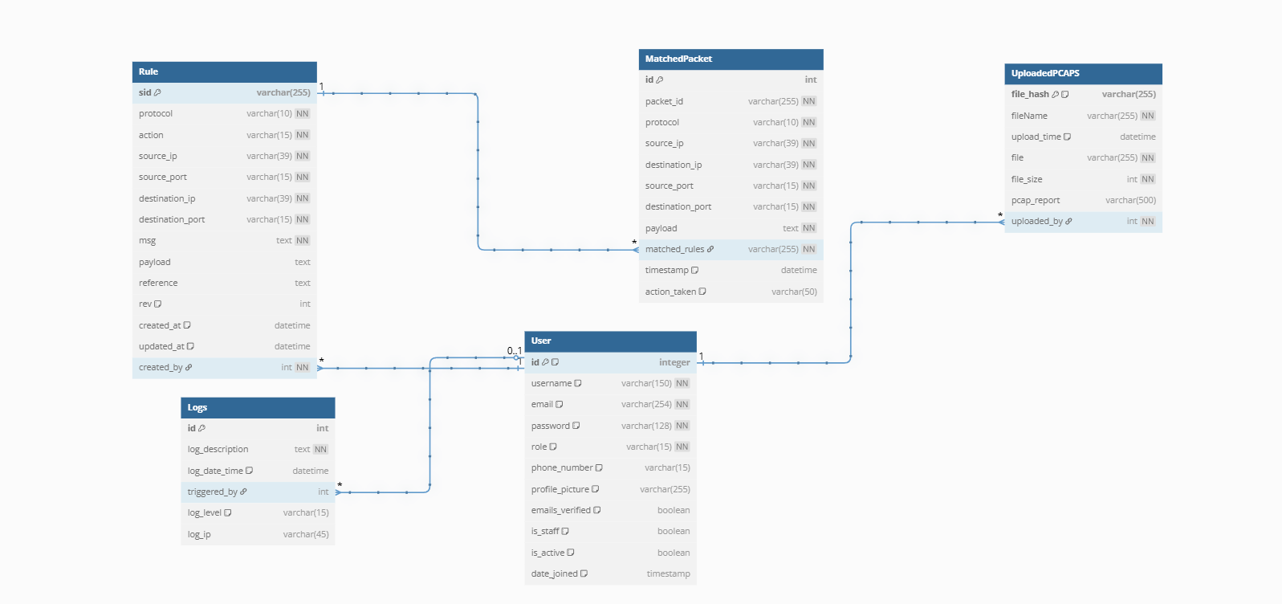

Figure 2: Entity Relationship Diagram Final Iteration

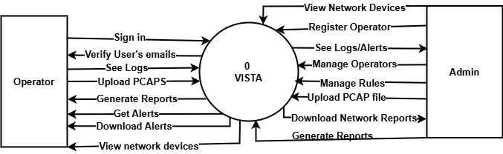

Figure 3: Level 0 Data Flow Diagram

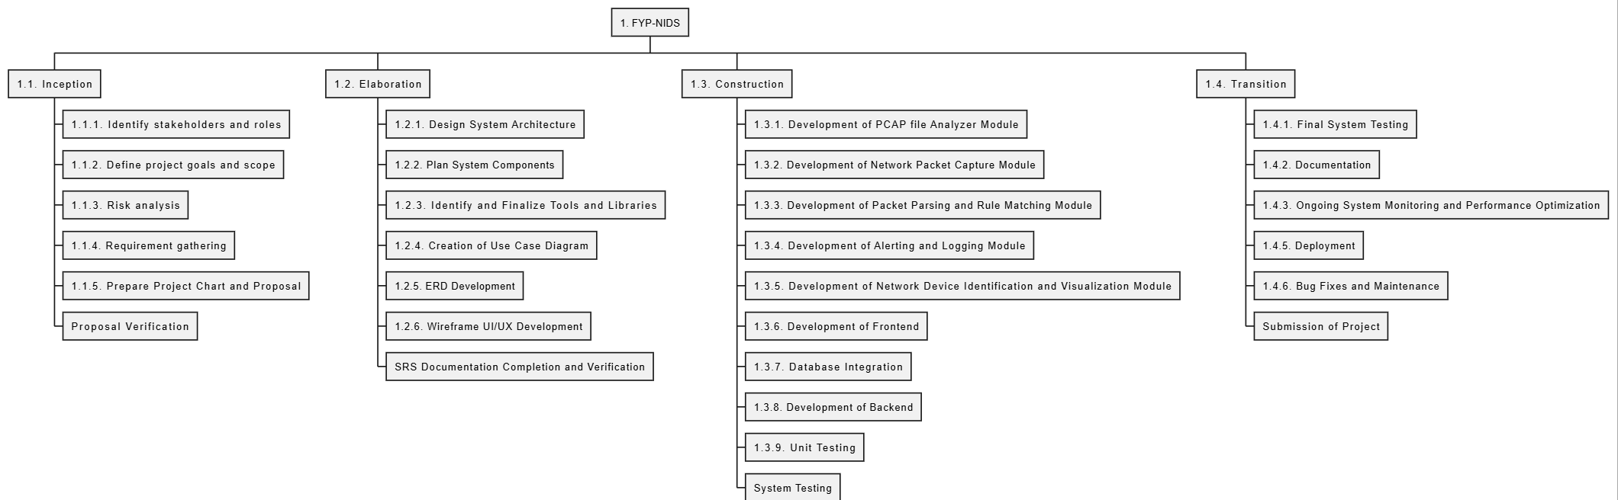

Figure 4: Project Work Breakdown Structure

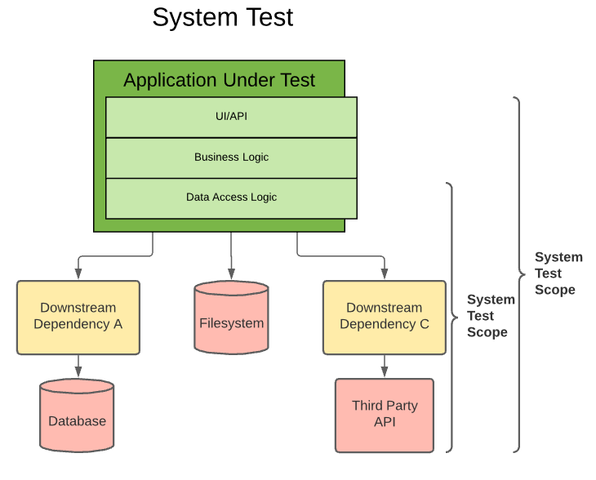

Figure 5: System Test

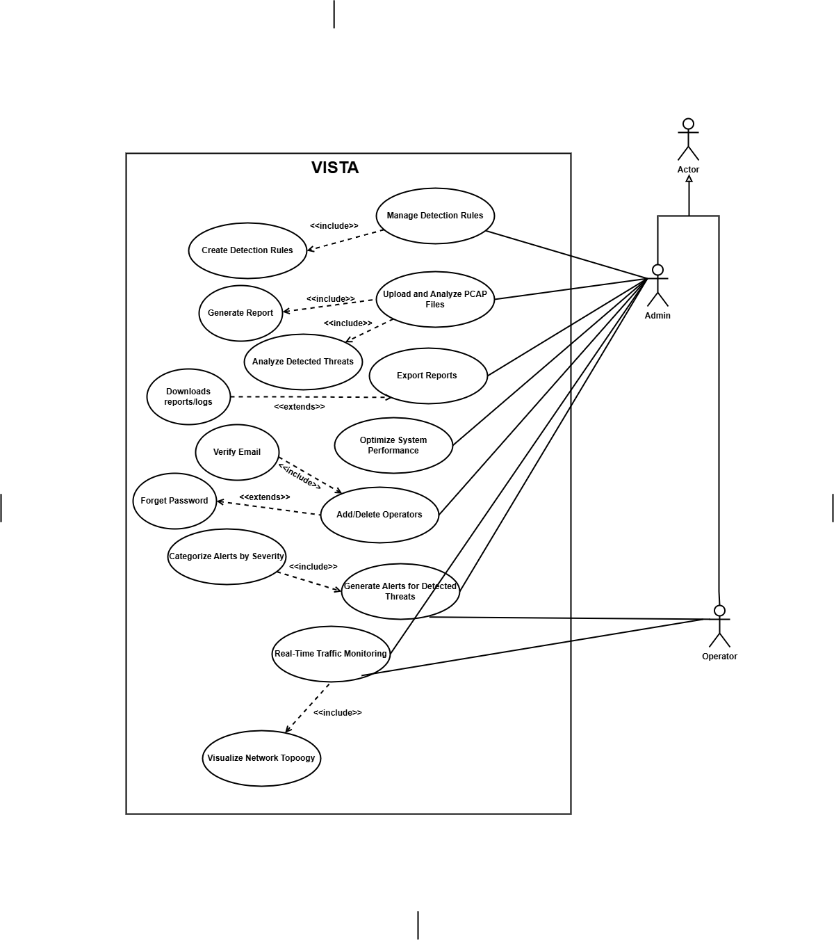

Figure 6: Use Case Diagram